**PROGRAMMING FUNDAMENTALS LAB**

**LAB 2 ASSIGNMENT**

**COURSE CODE CL-1002**

**SYED M. SHUJA UR RAHMAN**

**ROLL NO. 22K-4456**

**MS. AYESHA ALI**

**EXERCISE: 2**

**Question:1**

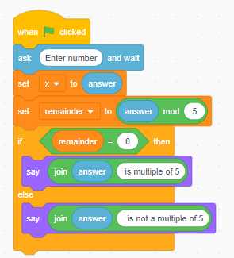Take a number as an input from a user. Check if whether a number is multiple of 5 or not. If it is then print “This number is multiple of 5”, otherwise print “This number is not multiple of 5”

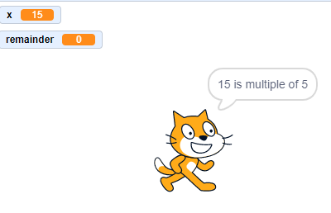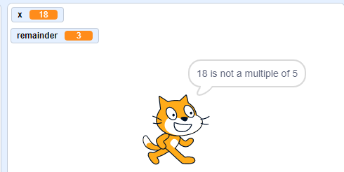

**Question: 2**

Create a calculator asking for operator (+ or – or * or /) and operands and perform calculation according to the user input.

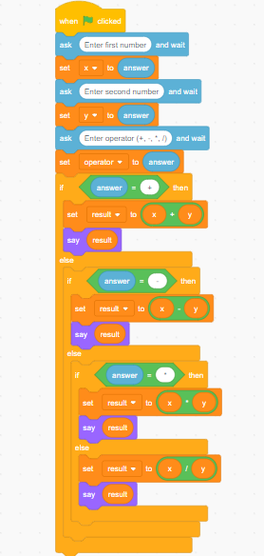

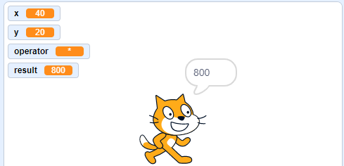

**Question: 3**

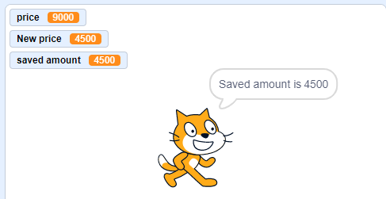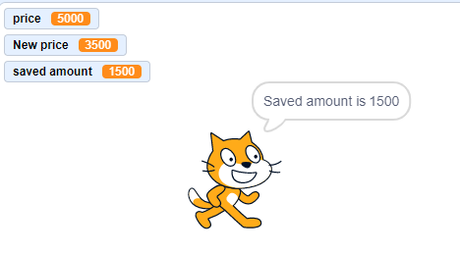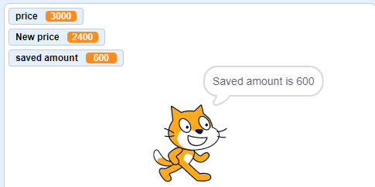An online shopping store is providing discounts on the items due to the Eid. If the cost of items is more than 1999 it will give a discount up to 50%. If the cost of shopping is 2000 to 4000, a 20% discount will be applied. If the cost of shopping is 4001 to 6000, a 30% discount will be applied. If it's more than 6000 then 50% discount will be applied to the cost of shopping. Print the actual amount, saved amount and the amount after discount.

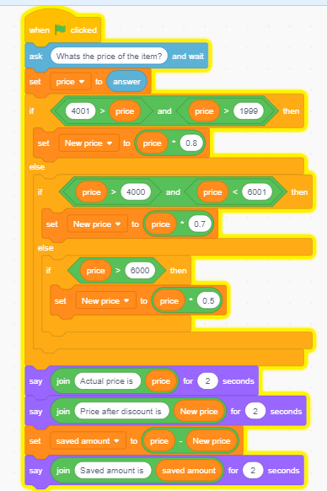

**Question: 4**

You are supposed to create a mark sheet. There are total five subjects. Each subject has equal marks i.e., 100, therefore total marks are 500. Take marks of five subjects as an input from the user. Calculate the percentage. If the percentage is below 50, he/she is fail else he/she is pass. Draw a flowchart on your notebook. Convert the flowchart into scratch diagram.

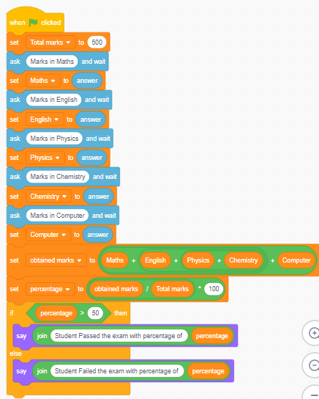

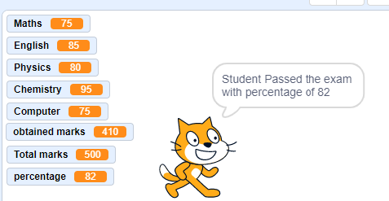

**Question: 5**

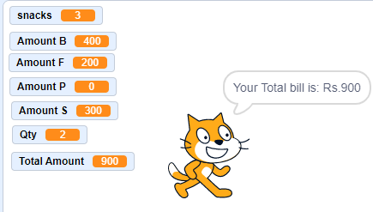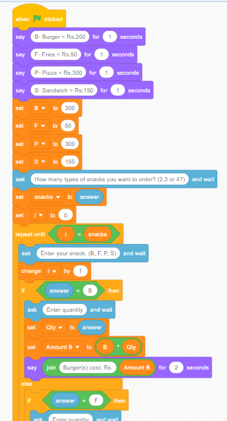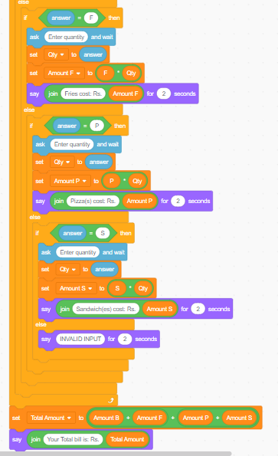Using IF, displays the following menu for the food items available to take order from the customer: ***B= Burger (Rs. 200) ∙ F= French Fries (Rs. 50) ∙ P= Pizza (Rs. 500) ∙ S= Sandwiches (Rs. 150)***. The costumer can order any combination of available food. The program first asks to enter the no of types of snacks i.e. 2, 3 or 4 then it ask to enter the choice i.e. B for Burger and then for quantity. The program should finally display the total charges for the order.

**Question: 6**

Given below is a flow chart. Identify the decision and iterative structures in it. Convert the flow chart in to scratch diagram.

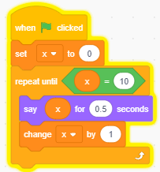

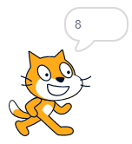

**Question: 7**

Given below is a scratch diagram. Write a description of the diagram as well as draw its flowchart on your notebook.

Start

In this flowchart the variable “Some Number” is set to 42 and then the iterator is used. If the number is greater than 30, the condition statement will check whether the variable is greater than 35 or not. If the condition is true, the variable will be changed by -5, if it is false then the variable will be subtracted by 2 with its own value. This process would go on until the variable becomes less than 30.

Some Number = 42

YES

END

Some Number< 30?

NO

YES

Some number = some number - 5

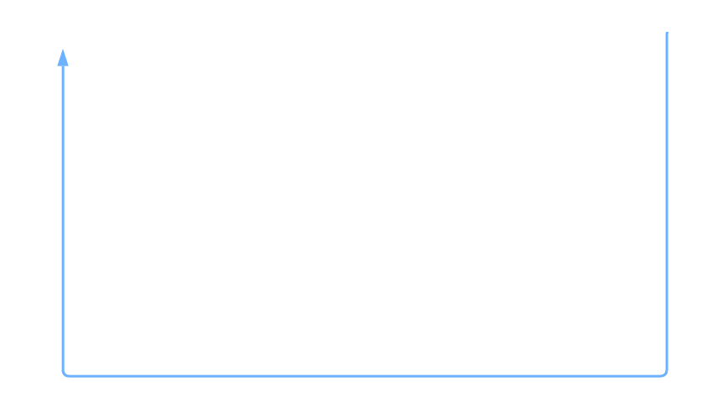

Is some number >35

NO

Some Number =Some Number - 2